

FPT APTECH – T2307A



CARSORE

Semester: 3

Group: 3

Members: 5

1. Do Xuan Truong
2. Nguyen Nhu Vu
3. Bach Ngoc Anh
4. Nguyen Thanh Van
5. Le Quang Huy

Instructor : Mr. Vu Huu Phuong

Contents

Problem Definition 1

Introduction 1

Problem statement 1

TOOL AND TECHNOLOGY USED 2

USE CASE BY USER 3

USE CASE BY ADMIN 5

FOLOW CHART USER 6

FOLOW CHART ADMIN 7

DATABASE DESIGN 8

WEB DESIGN 9

HOME 9

ABOUT US 14

SERVICES 16

BLOG 17

CONTACT US 19

LOGIN 21

REGISTER 22

ADMIN 23

# Problem Definition

## Introduction

In today's world, computers play a crucial role across various sectors. Information technology has profoundly impacted almost every aspect of our lives. This project aims to enhance the record-keeping operations of Vehicle Insurance by introducing automation, making the process more efficient and streamlined.

Currently, the manual system used in vehicle insurance operations is highly labor-intensive, prone to errors, and inefficient. The system requires a significant amount of time and effort, making the process difficult for both employees and customers. There is also a higher risk of unauthorized access and data mismanagement, which further complicates operations.

The primary objective of this project is to automate many of the manual processes involved in vehicle insurance. The software will help reduce the reliance on human resources, minimize paperwork, and offer improved security against unauthorized access. Additionally, it will facilitate the generation of complex reports required for various managerial functions, leading to better decision-making and smoother overall operations.

## Problem statement

In today's fast-paced world, traditional insurance processes often involve time-consuming paperwork, manual data management, and limited accessibility for customers and agents. This outdated approach leads to inefficiencies in policy management, claim processing, and customer service. Furthermore, the lack of a centralized system makes it difficult for insurance companies to track sales, monitor claims, and generate insightful reports, which hampers overall operational effectiveness.

Customers face challenges such as limited options to purchase or renew policies online, difficulty accessing policy details, and delays in claim initiation and processing. Agents and administrators struggle with managing large volumes of data, ensuring timely policy renewals, and maintaining accurate expense and revenue records. These issues not only impact customer satisfaction but also hinder the company’s ability to adapt to a competitive digital environment.

To address these challenges, there is a need for a **comprehensive, web-based Online Insurance Portal** that streamlines the entire insurance lifecycle. The solution should enable easy policy purchase, efficient claim management, automated billing, real-time reporting, and secure data handling, ensuring improved productivity and enhanced customer experiences.

# Tool and Technology used

For this project, we are using 3 tools which are:

* Visual Code Studio
* Github
* MySql

The following technologies are also being used to achieved our goals:

HTML JAVA SCRIPT

 

CSS BOOTSTRAP

 

ASP.NET MVC



# USE CASE BY USER

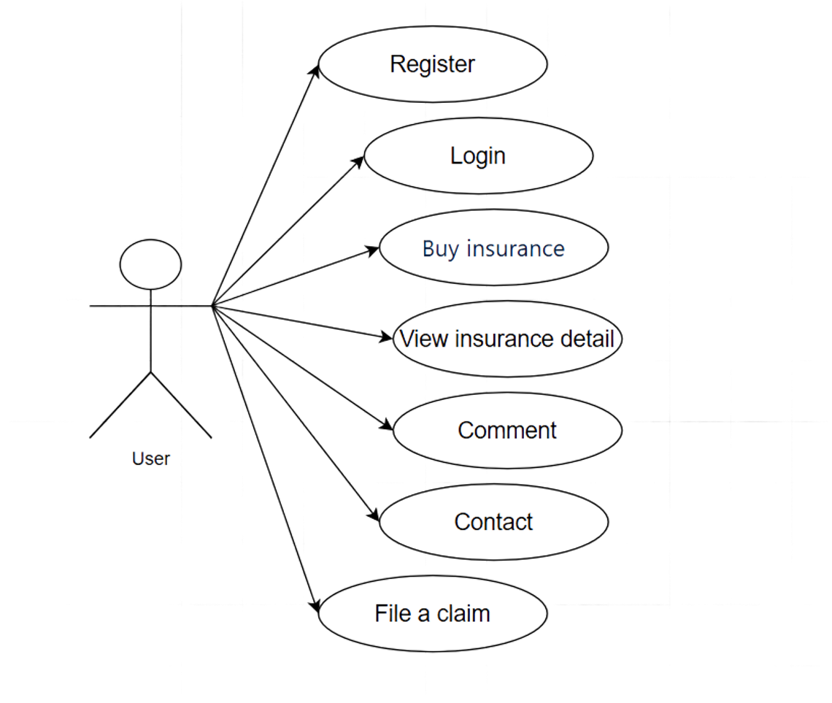

# USE CASE BY ADMIN

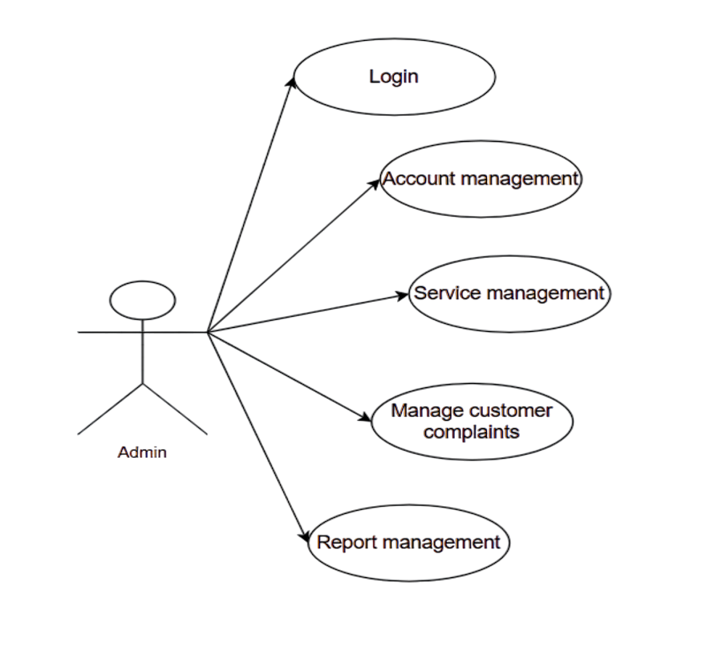

# FOLOW CHART USER

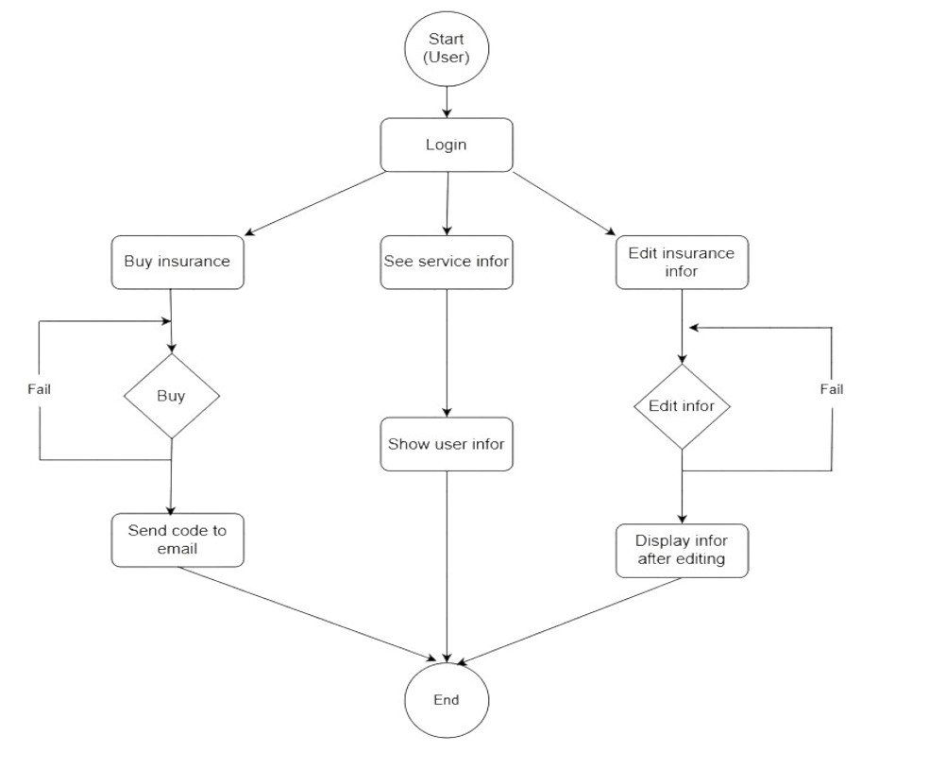

# FOLOW CHART ADMIN

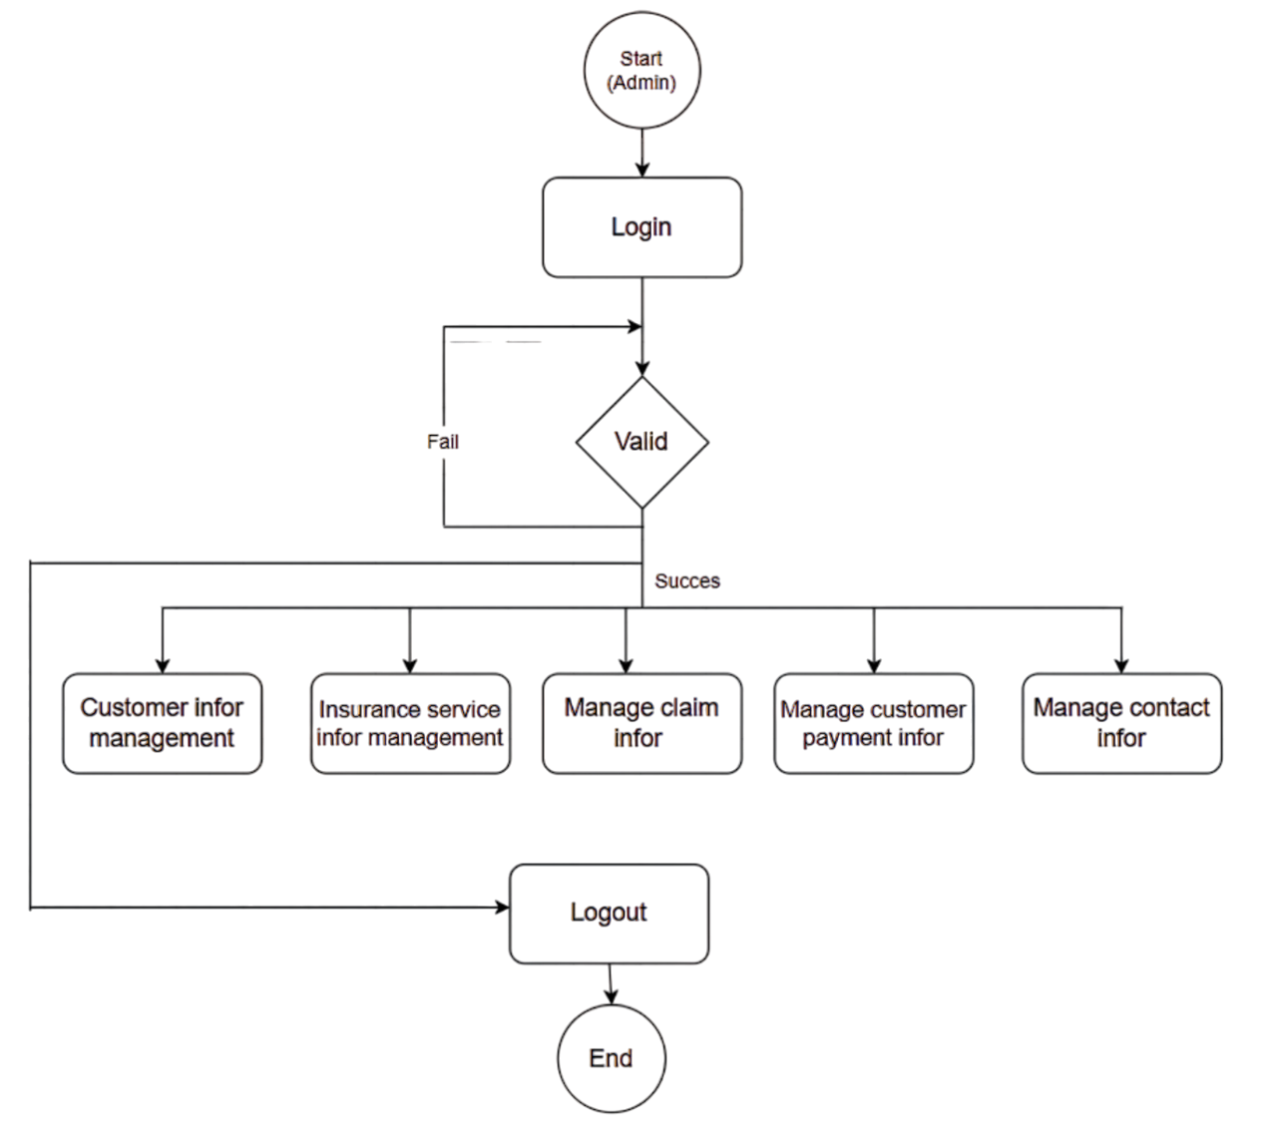

# DATABASE DESIGN

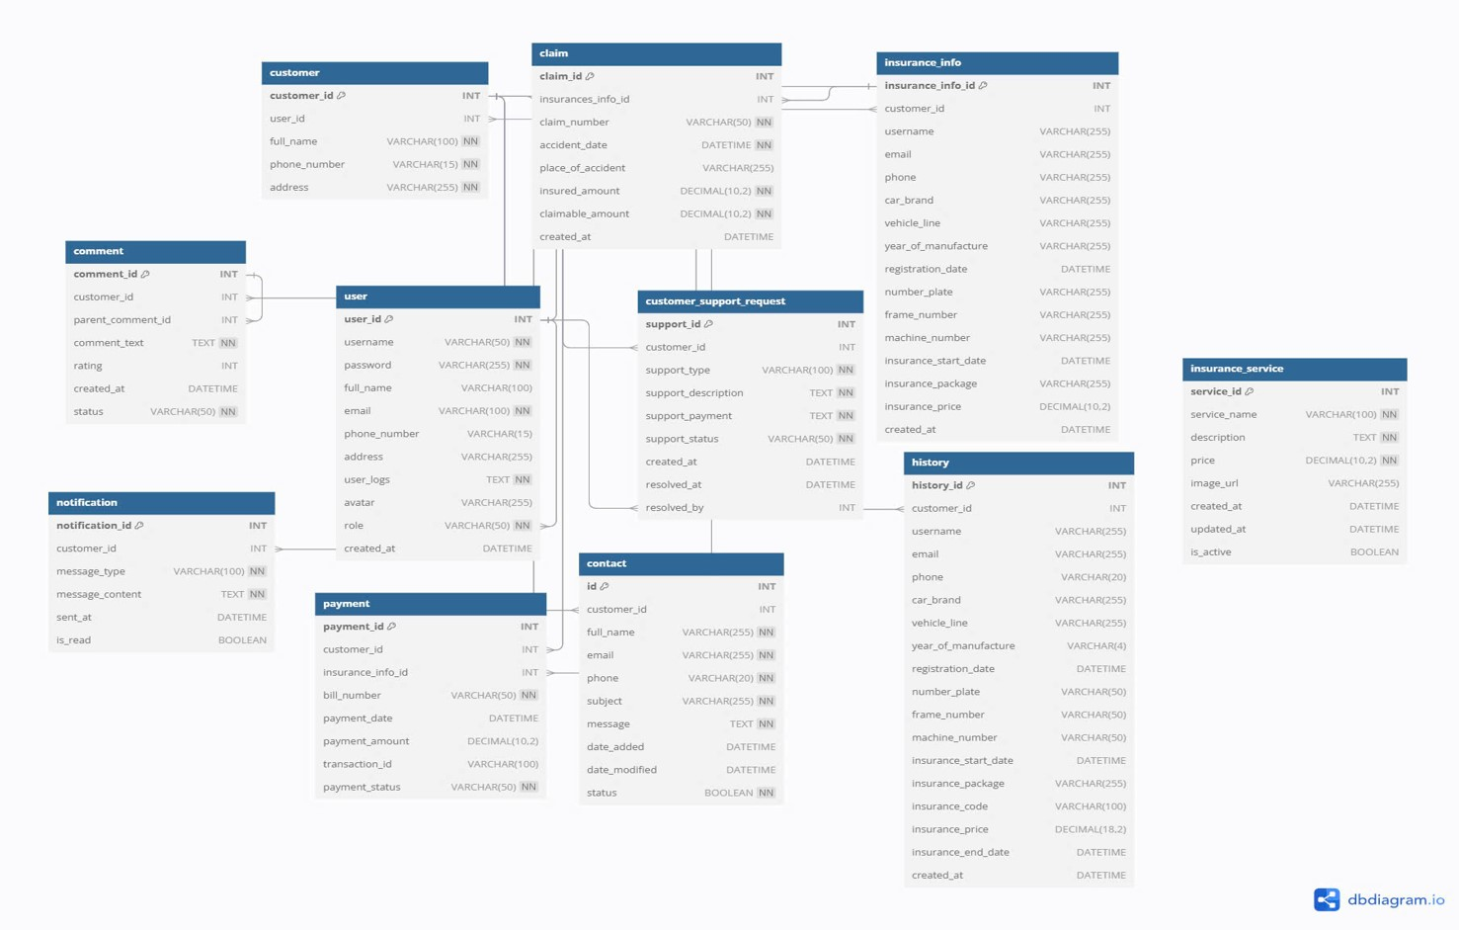

# WEB DESIGN

## HOME

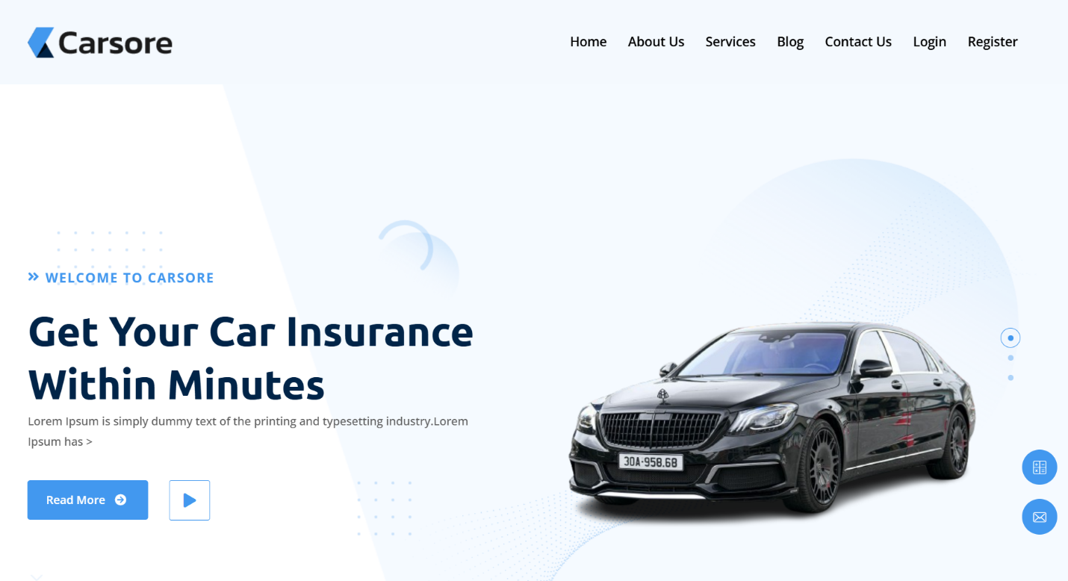

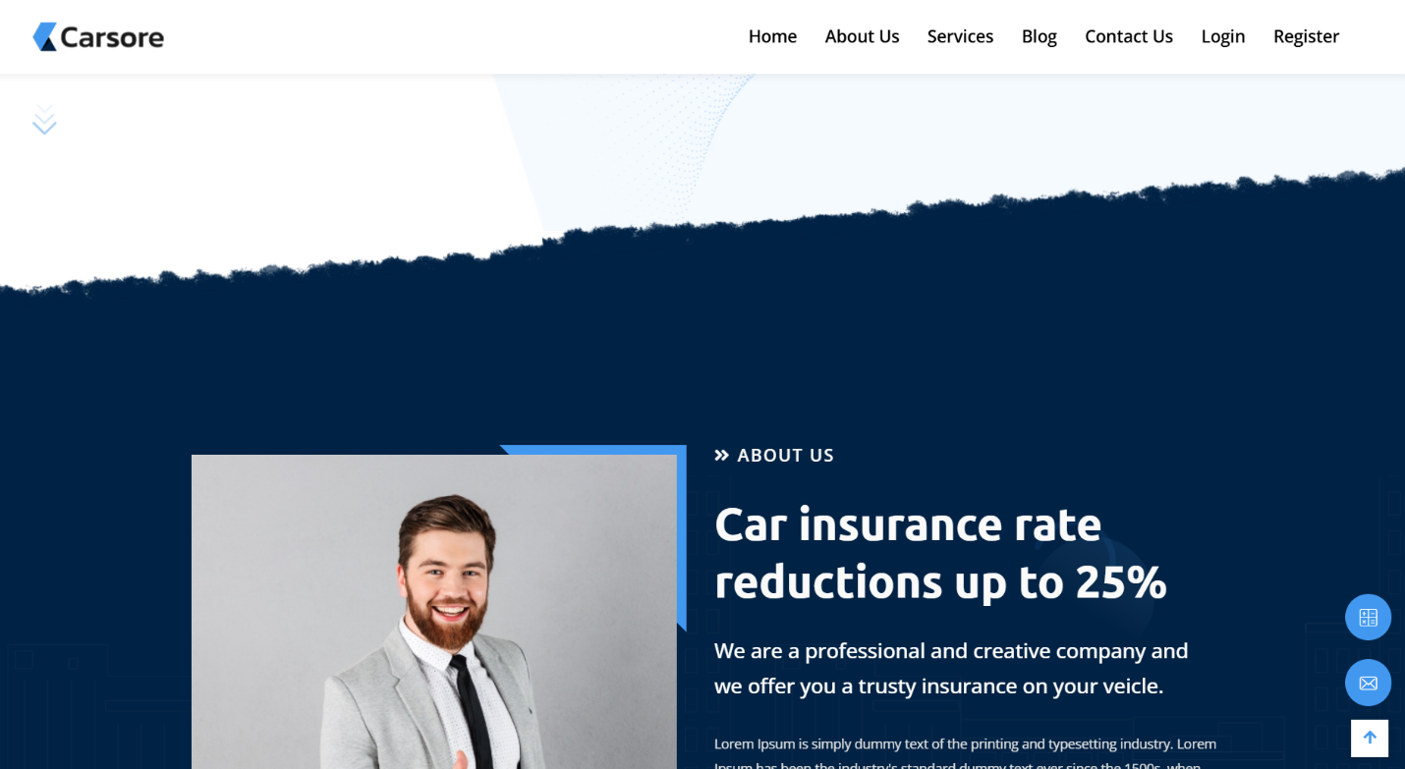

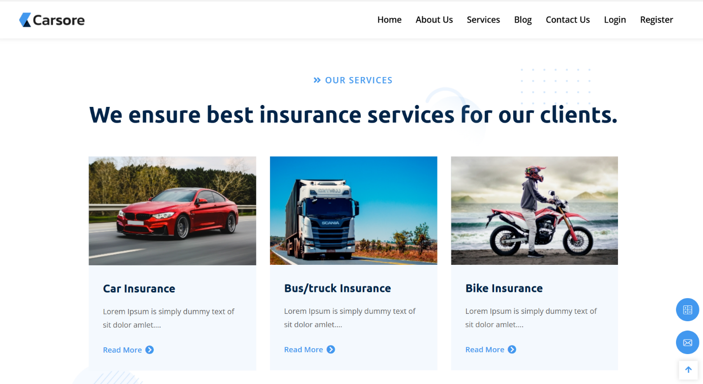



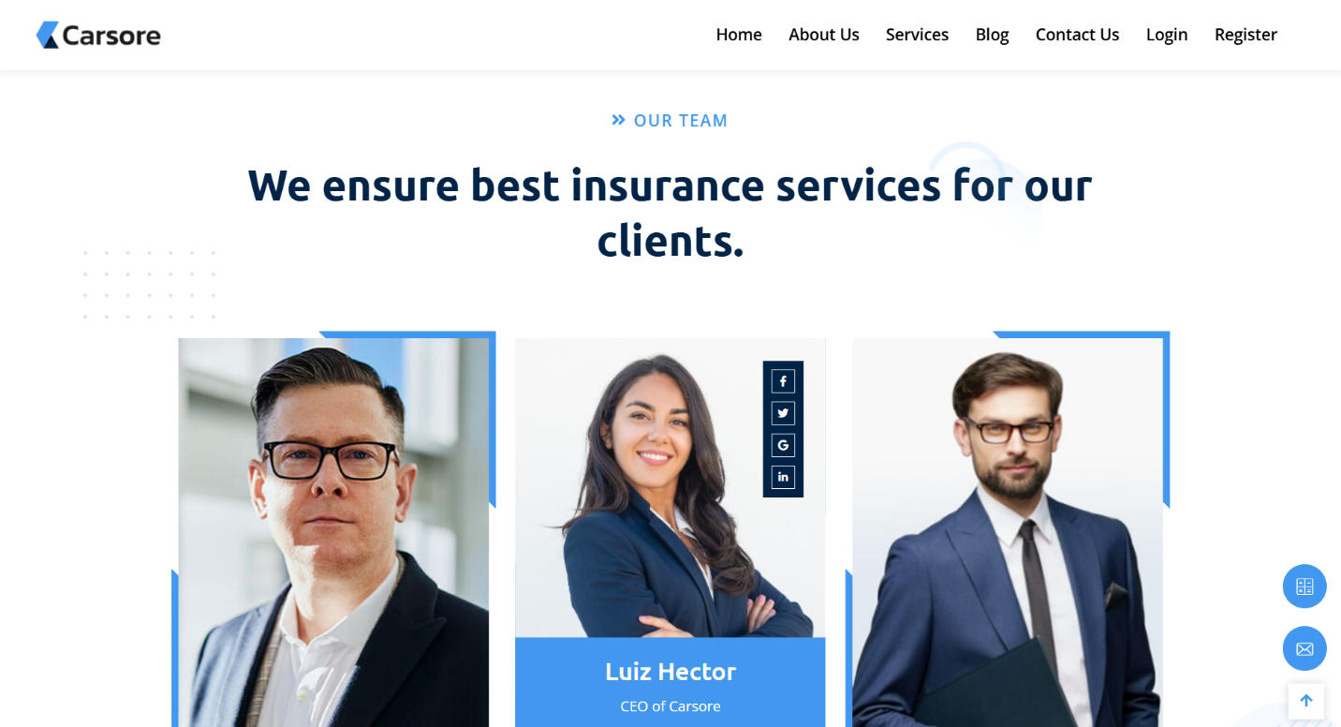

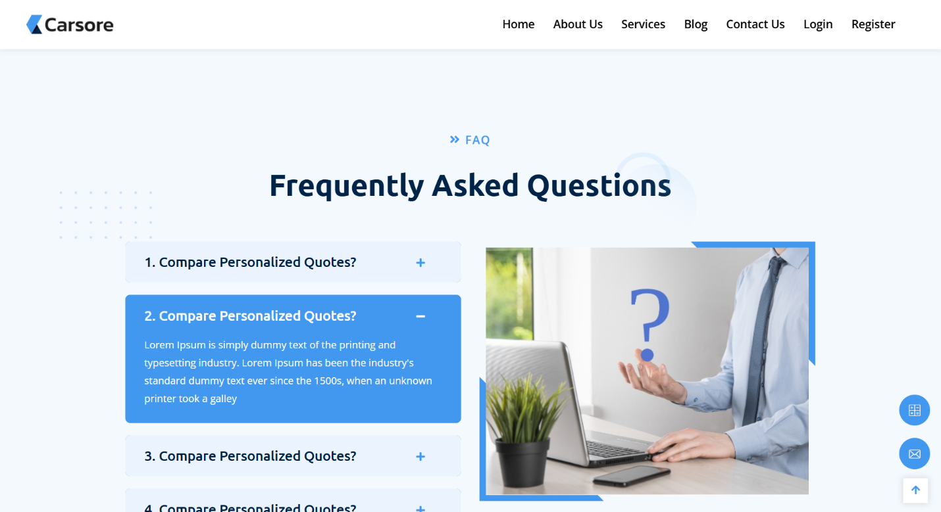

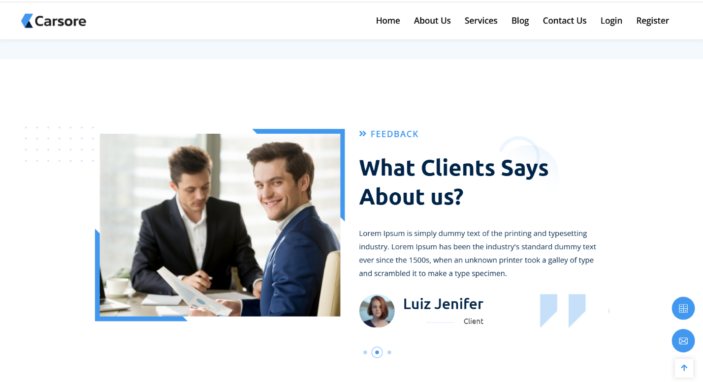

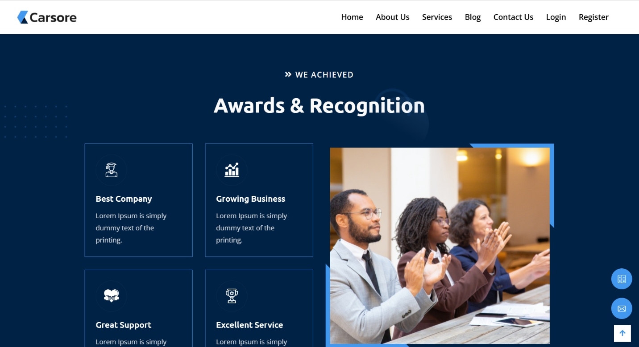

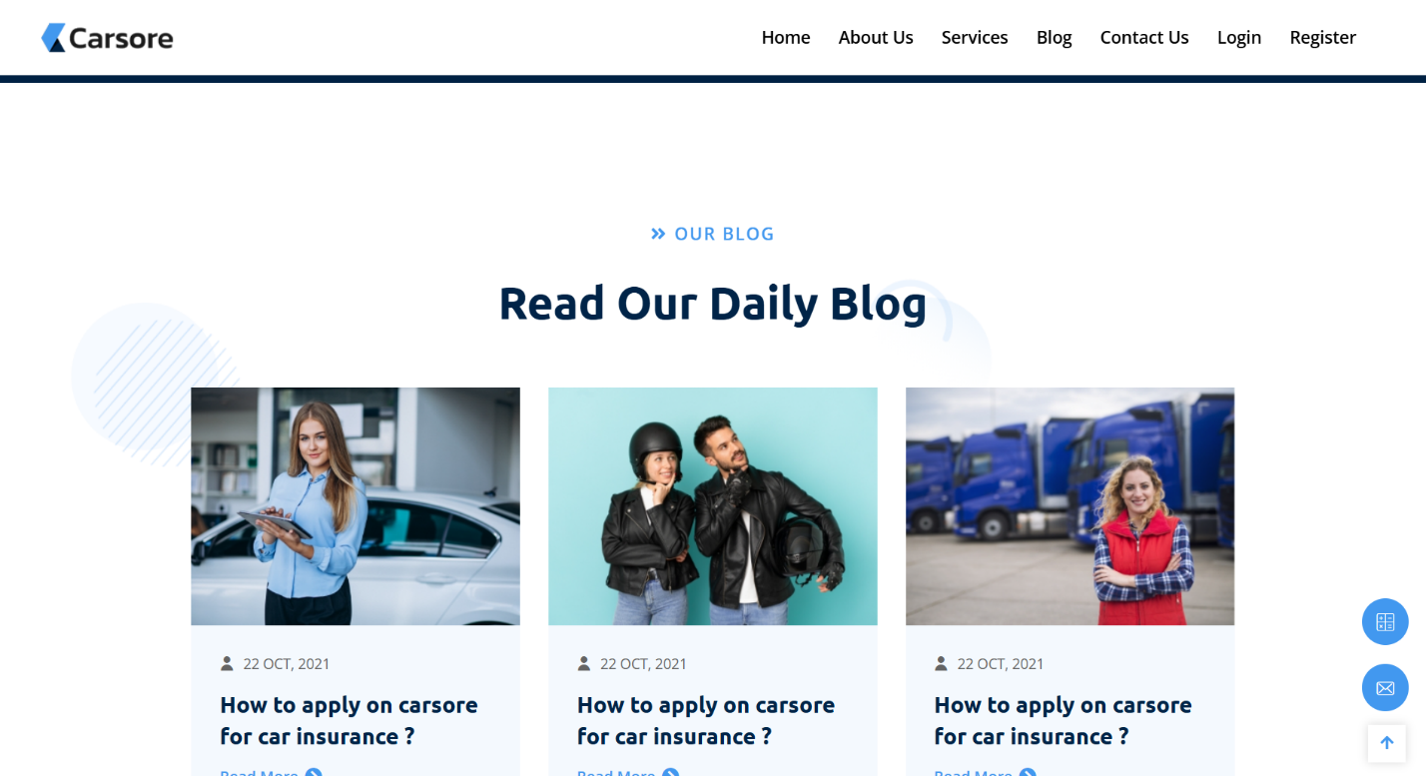

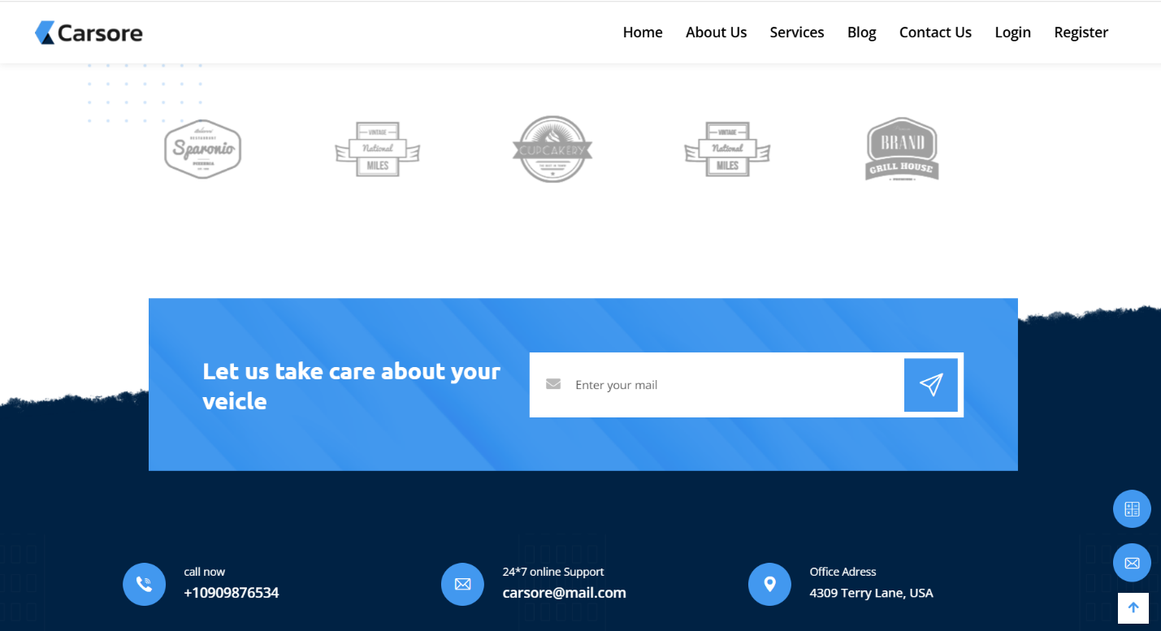

## ABOUT US

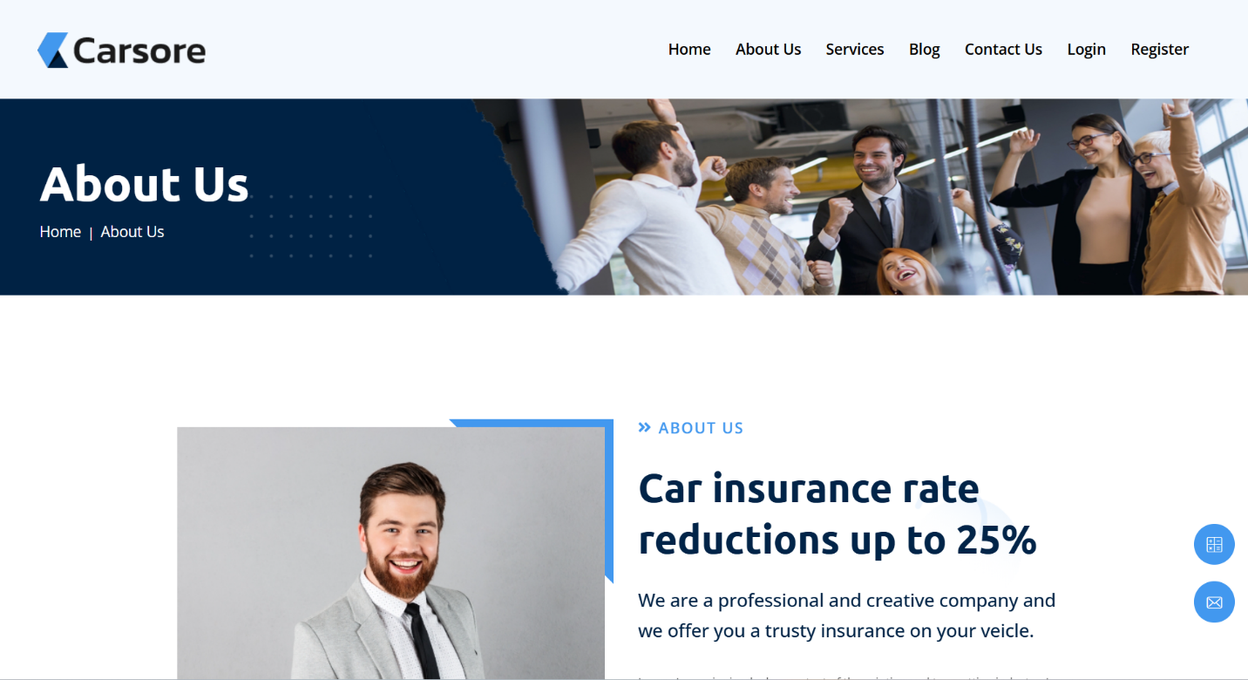

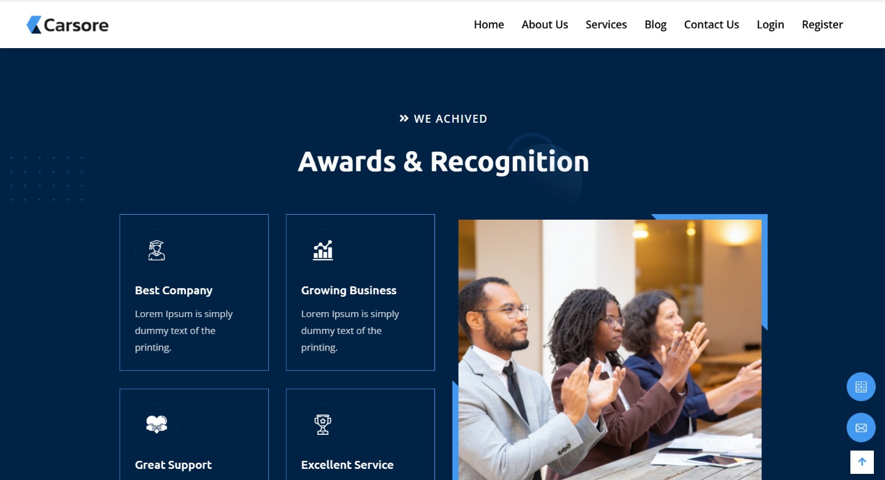

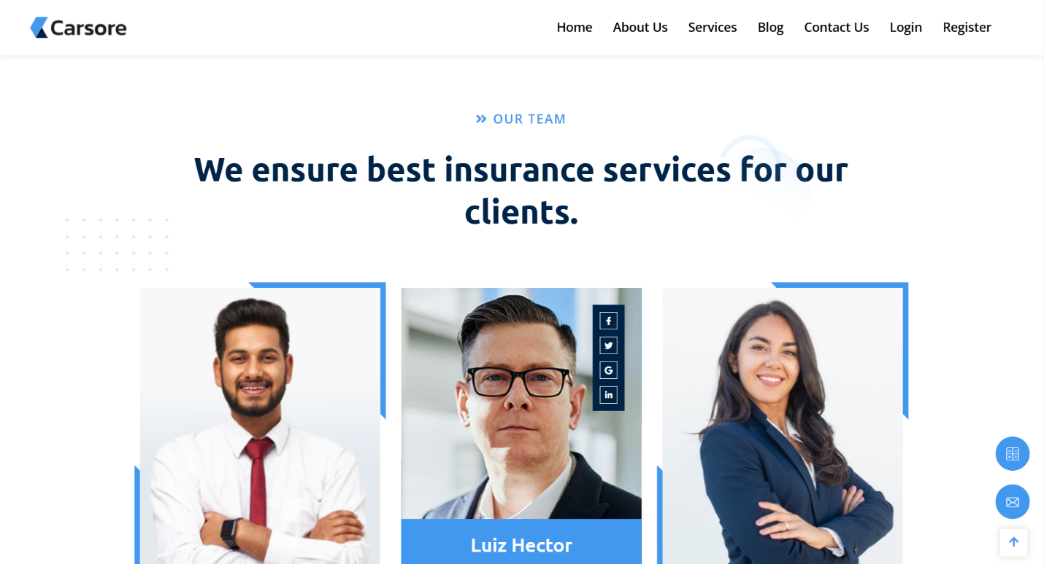

## SERVICES

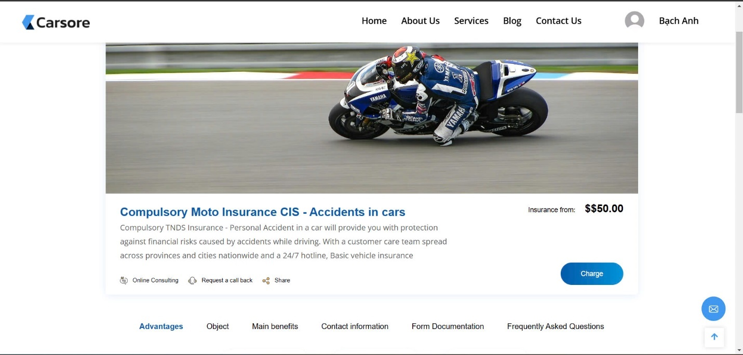

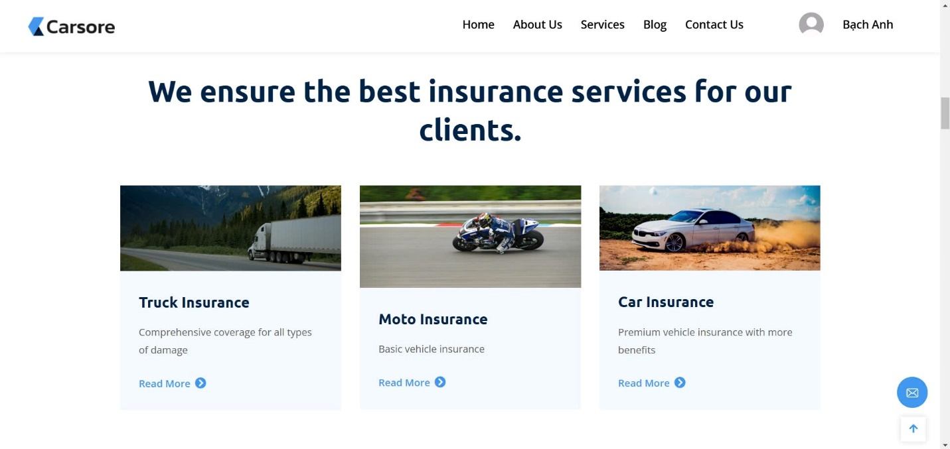

## BLOG

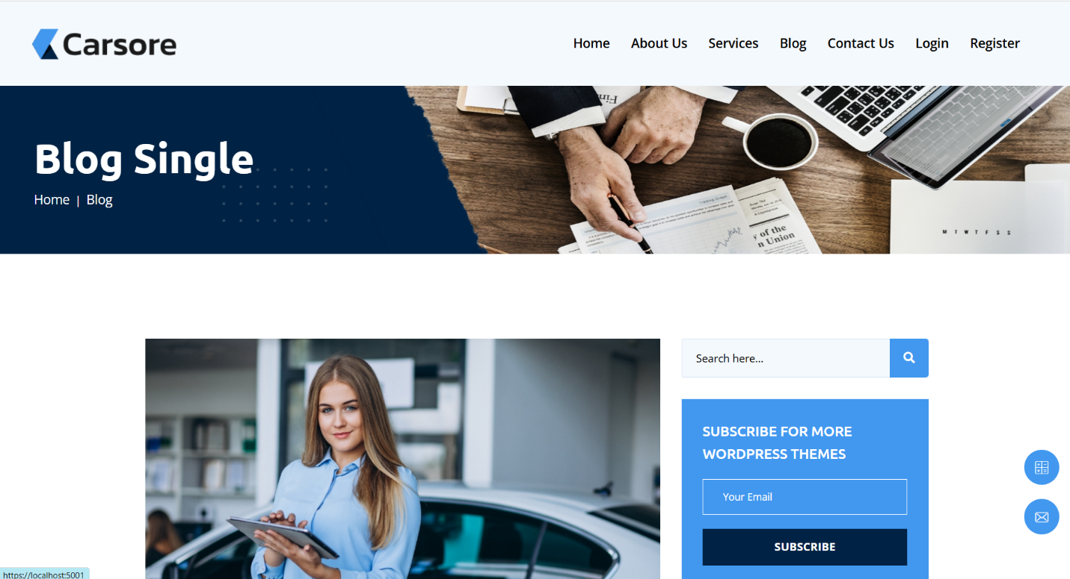

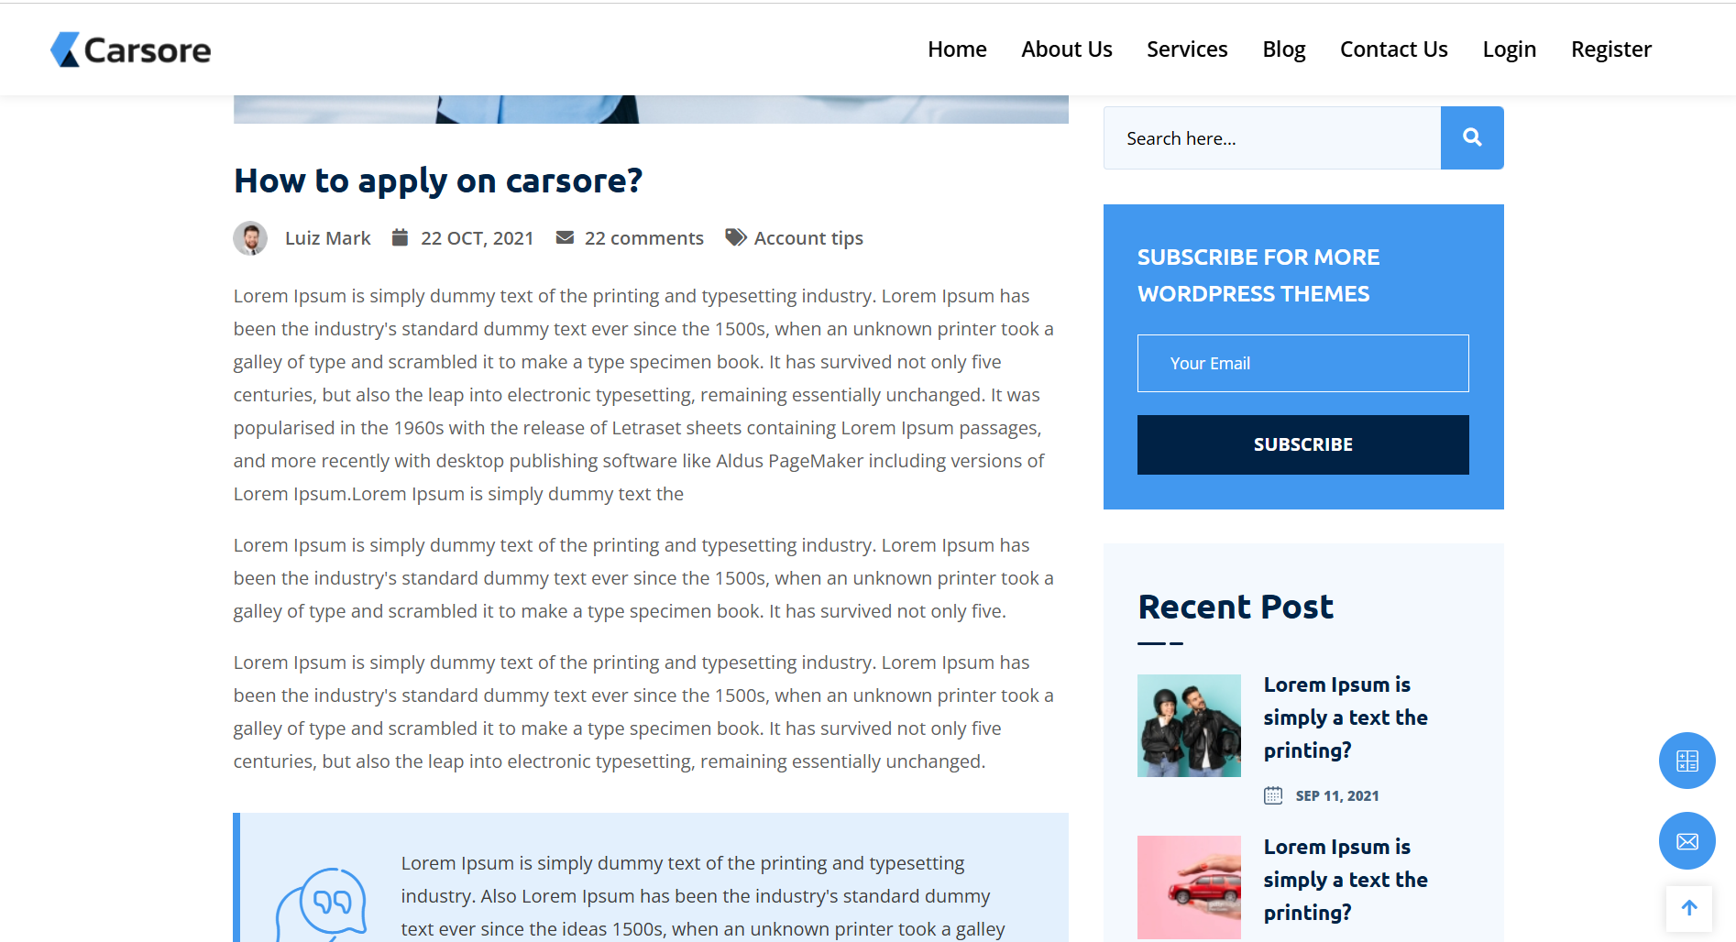

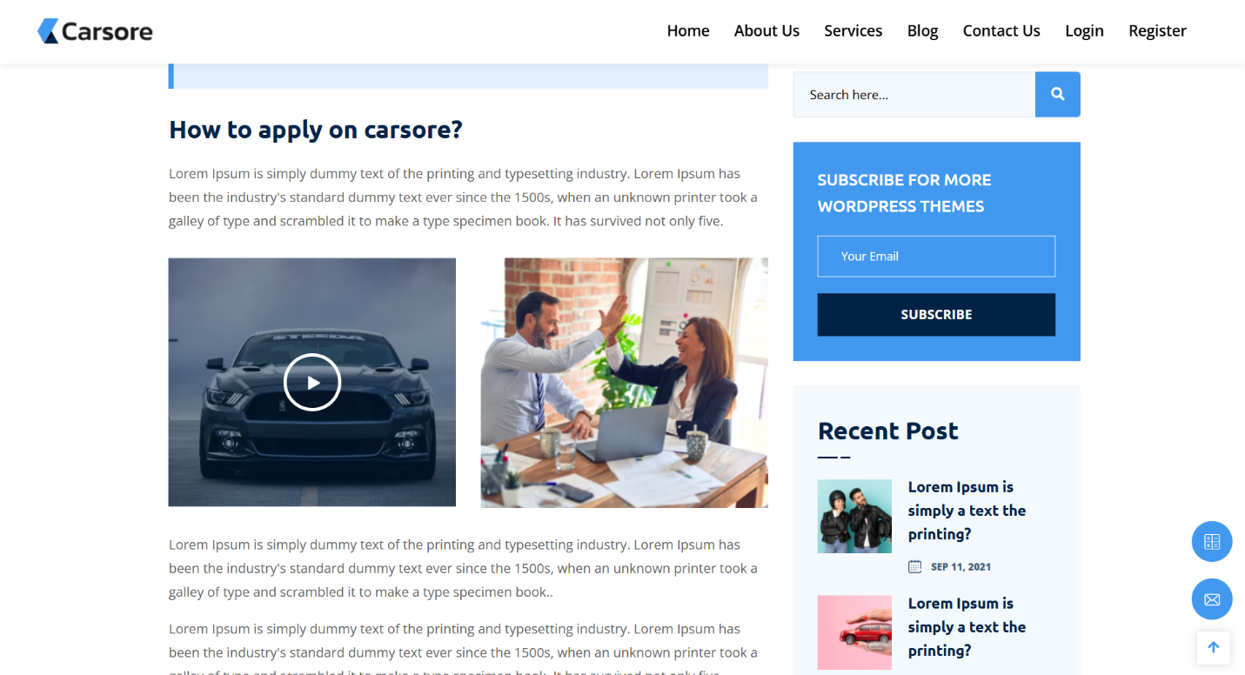

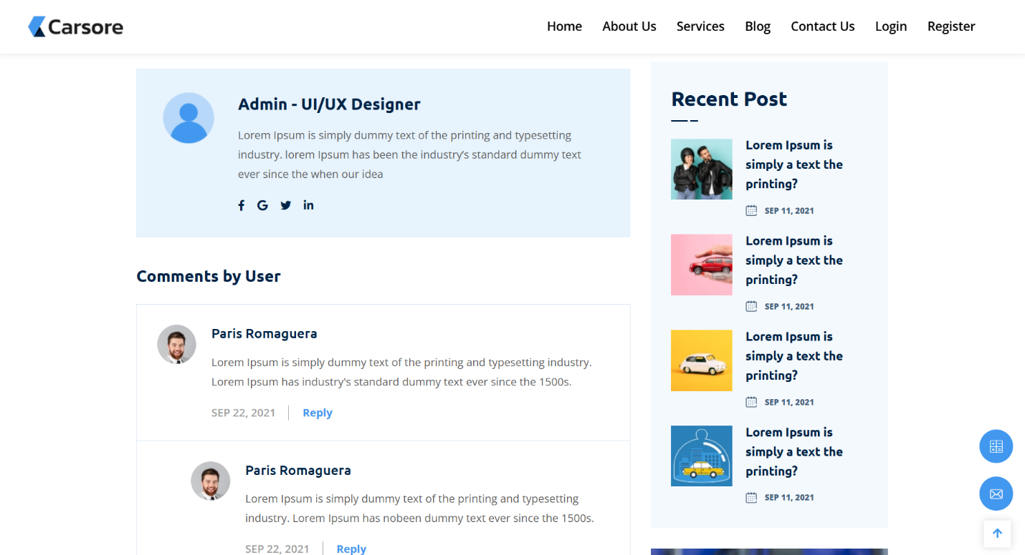

## CONTACT US

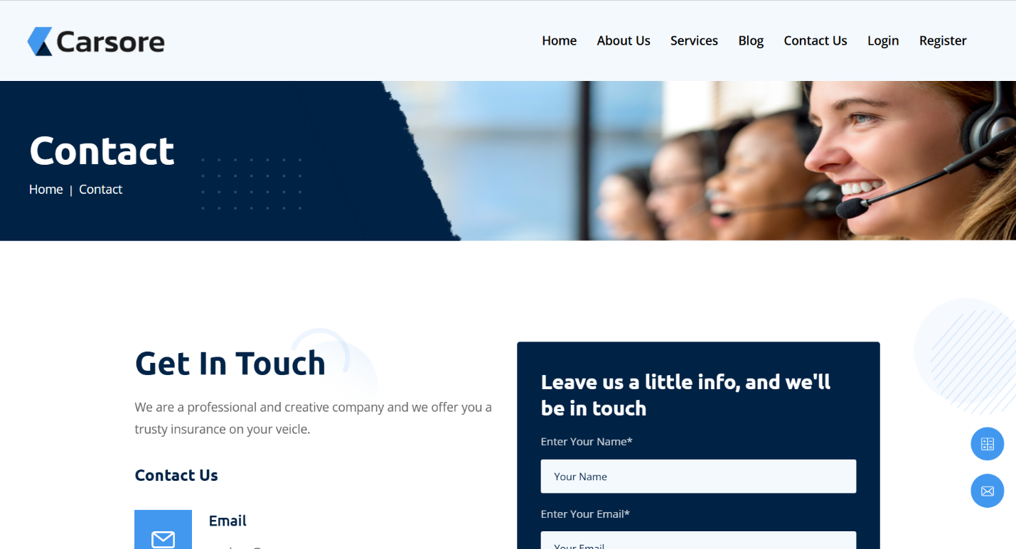

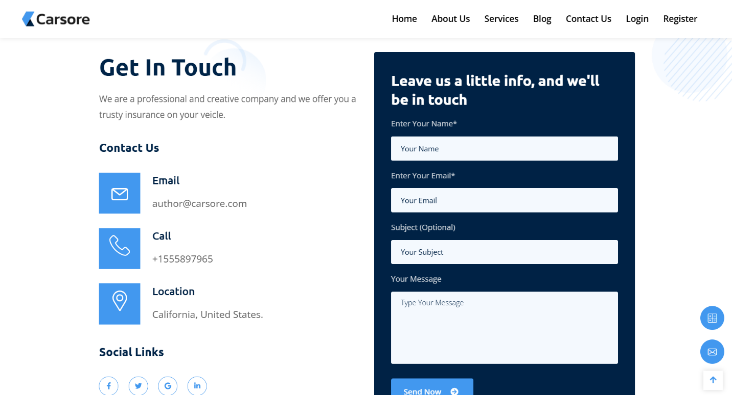

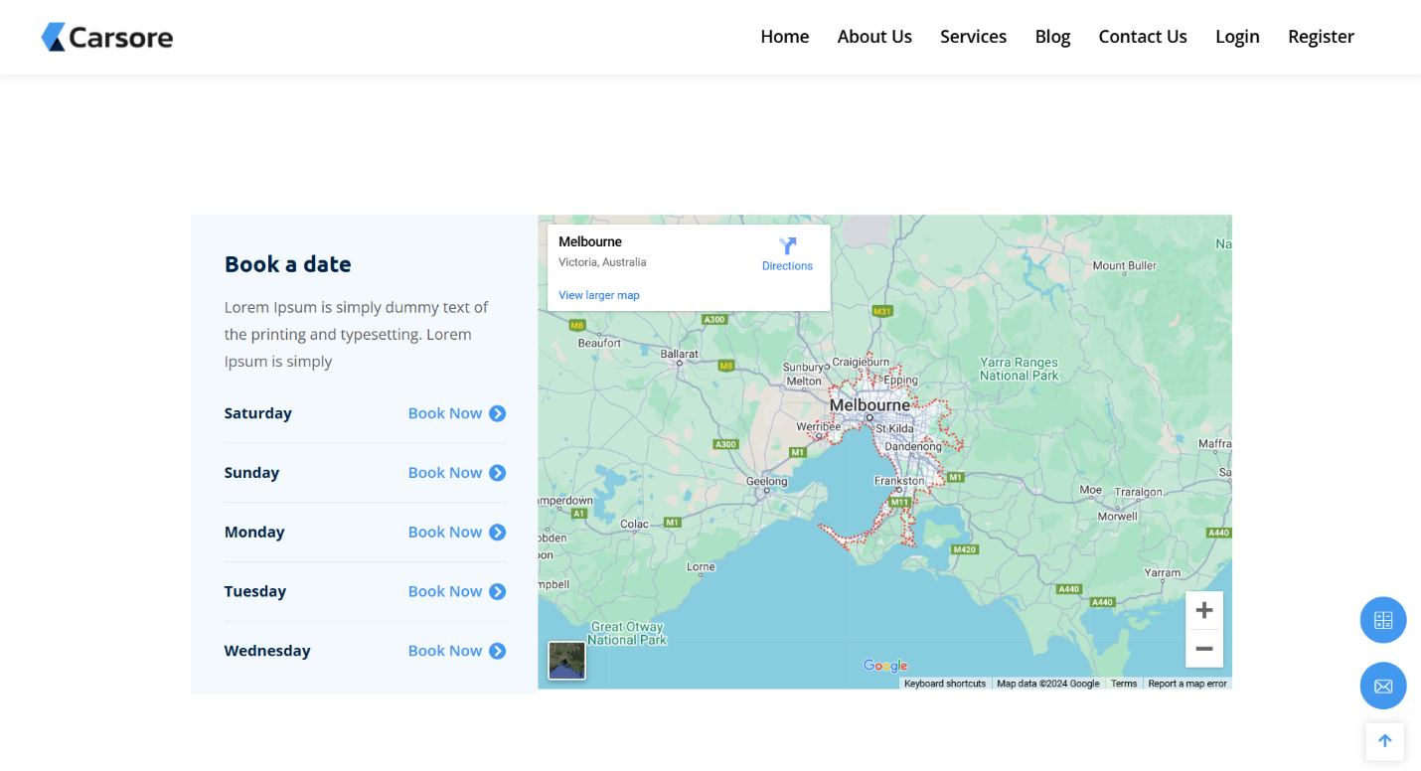

## LOGIN

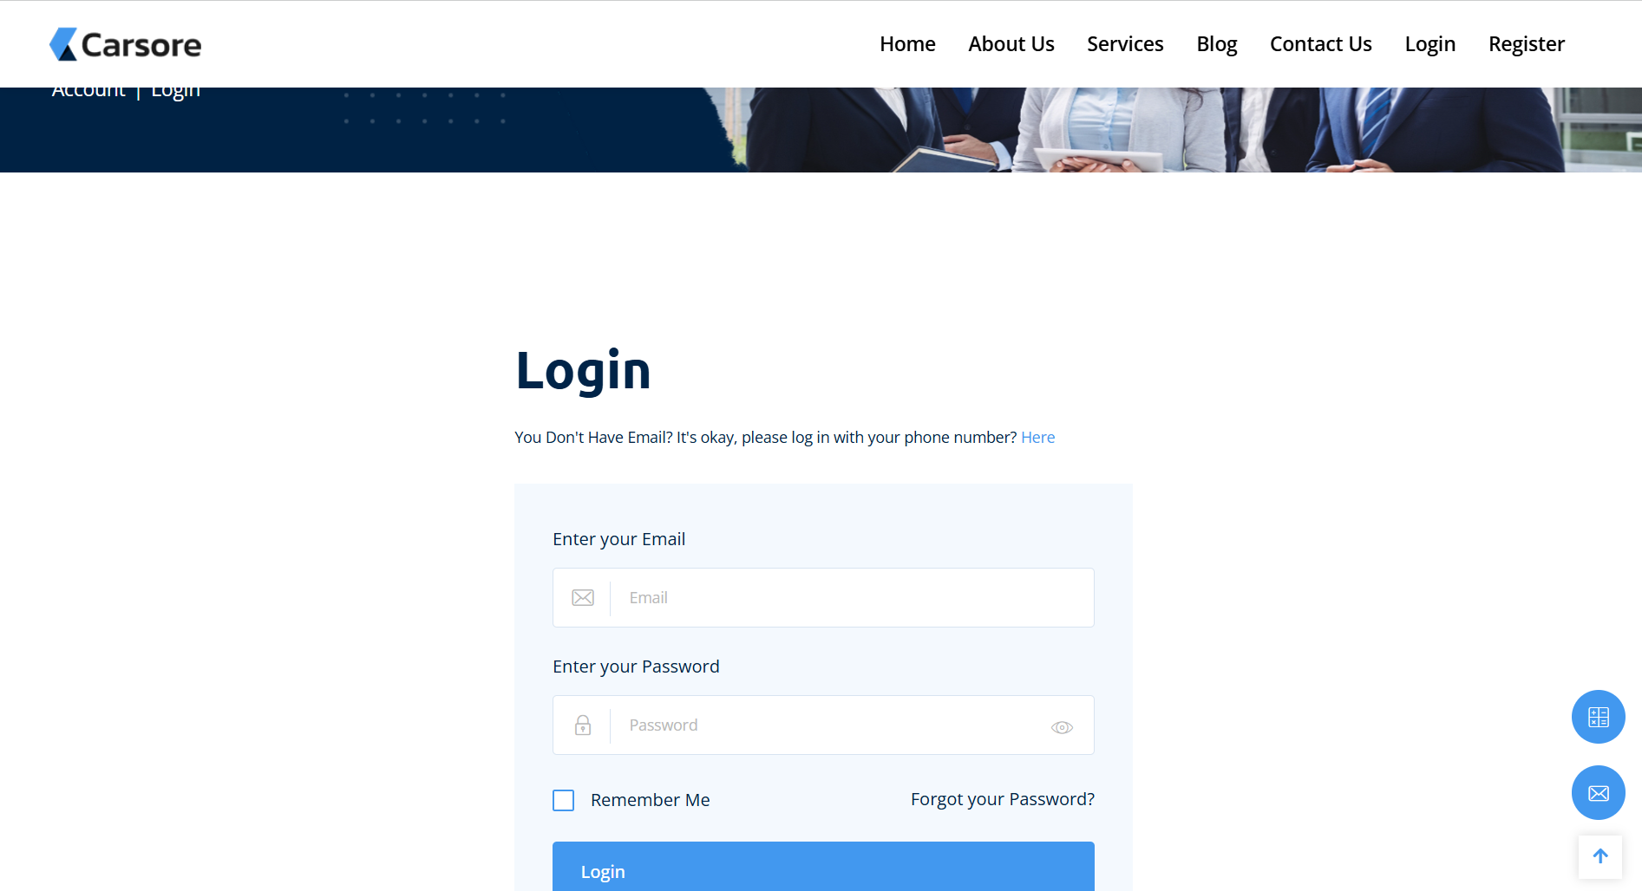

## REGISTER

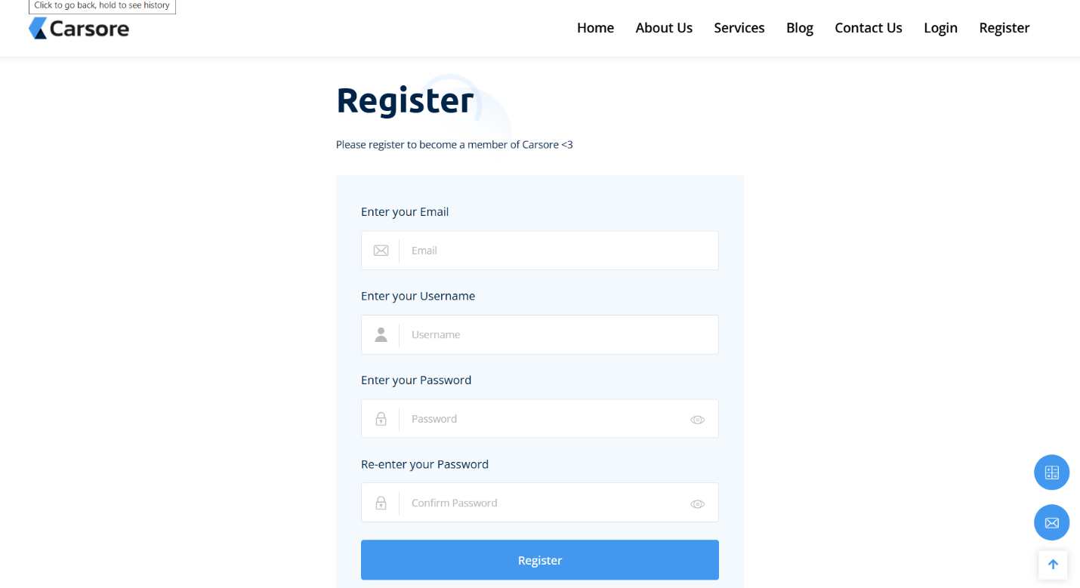

## ADMIN

